**CREATING CLARITY USER AND ASSIGINING DEFAULT ROLES**

**Before Automation**

1. **Check whether the user account has been already existed in the database.**



1. **If it doesn’t exist, Create the user account manually by using the below query.**

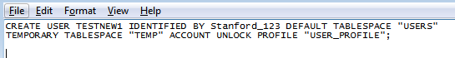

1. **After creating the user accounts. Assign the roles as mentioned below,**

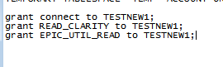

**After Automation**

1. **Checking the details of user to be replicated**

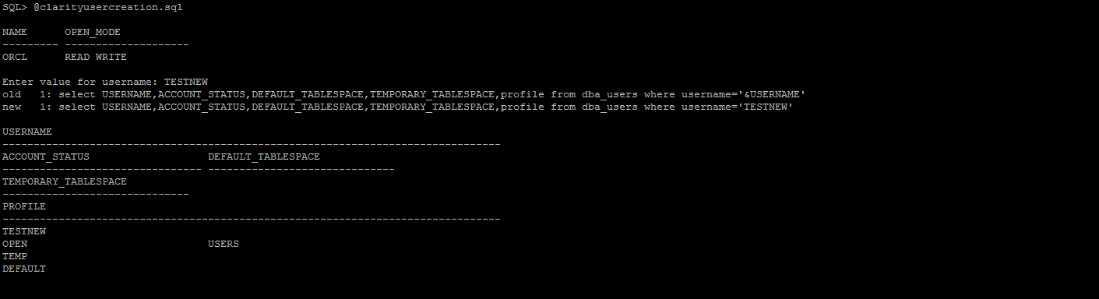

1. **User creation**

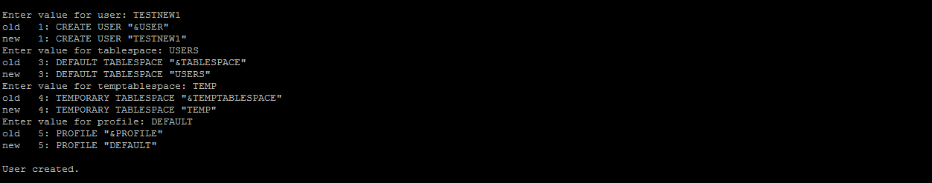

1. **Assigning roles to the new user created.**



1. **Checking the status of the new user created.**



